GUMBO Program Stakeholder Pledge
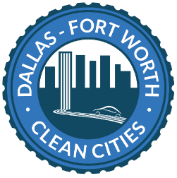

North Central Texas Council of Governments
Dallas Fort-Worth Clean Cities
616 Six Flags Dr, Centerpoint Two
Arlington, TX 76011
cleancities@nctcog.org
[Date]
To Whom It May Concern,
We, the undersigned, on behalf of [Organization Name], hereby express our interest in and support of the Electric Vehicle Supply Equipment (EVSE) Technician Training curriculum at a local education institution. We recognize the growing demand for trained professionals in the electric vehicle (EV) sector and the critical need to equip students with the necessary skills to support the installation, maintenance, and operation of EV charging infrastructure.
In light of this, [Organization Name] is committed to helping the success of this project through support and our industry partnership.
Sincerely,
[Name of Authorized Representative]
[Title]
[Organization Name]
[Email Address]
[Signature]

